
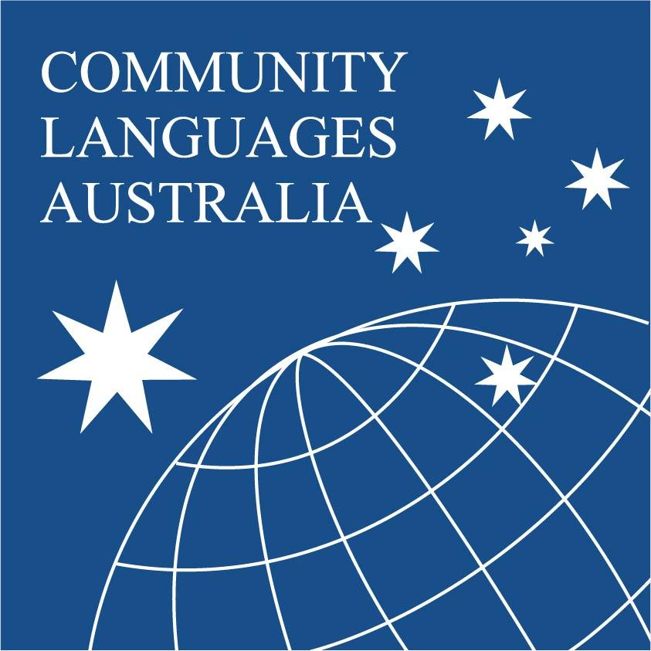
CHILD SAFE OFFICER
Job Description Example
CHILD SAFE OFFICER

School [INSERT SCHOOL NAME]
Location: [INSERT SCHOOL LOCATION]
Commitment to Child Safety:
[INSERT SCHOOL NAME] is committed to child safety. We have zero tolerance of child abuse, and all allegations and concerns for the safety and wellbeing of a child will be treated seriously and consistently according to our policies and procedures. We recognise that we have legal and moral obligations to contact authorities when we are concerned about a child’s safety, which we follow rigorously.
[INSERT SCHOOL NAME] want children to be safe, happy and empowered. We support and respect all children and are committed to the cultural safety of Aboriginal children, the cultural safety of children from a culturally and/or linguistically diverse background, and to providing a safe environment for children with a disability, children in out of home care and LGBTI children and young people.
[INSERT SCHOOL NAME] are committed to the safety, participation and empowerment of all children and employ a range of strategies to include their voices in the development of our programs and activities.
[INSERT SCHOOL NAME] is committed to preventing child abuse through the proactive identification of risks and the removal and reduction of these risks wherever possible. We have robust human resources and recruitment practices for all staff and volunteers and are committed to providing regular training and education for staff and volunteers.
[INSERT SCHOOL NAME] nominates one Child Safety Officer for each campus. The Officer must be up to date with child safety requirements and able to promote and effectively communicate with a range of stakeholders.
[INSERT SCHOOL NAME] have specific policies, procedures and training in place that support our leadership team, staff and volunteers to achieve these commitments.
Purpose: The Child Safe Officer is responsible for overseeing and implementing child safe practice across [INSERT SCHOOL NAME] to ensure compliance with the Victorian Child Safe Standards, Reportable Conduct Scheme, the National Child Safe Principles and the Victorian Early Years Learning and Development Framework.
The Child Safe Officer will be responsible for leading the process and review of implementing the Child Safety Manual.
Directly reports to:
- School Principal
- CLV Child Safe Officer
Key Responsibilities:
The Child Safety Officer is responsible for:
- Ensuring appropriate policies and procedures are in place to protect children and young people from abuse;
- Ensuring that a child safety policies and procedures are reviewed annually, (as directed by the School Principal, and CLV), and that the review includes school-wide consultation and input from staff, volunteers, committee members, children and young people and their families;
- Convening with key stakeholders regularly to discuss overarching matters related to child safety and the implementation of the child safety policy;
- Convening with key leaders on an urgent basis to support and guide decision making in the event of suspected child abuse, or breach of the child safeguarding policy.
- Overseeing the internal investigation of suspected child abuse in consultation with the internal stakeholders and external authorities;
- Providing guidance and support for staff and volunteers in relation to reports and matters of child safety;
- Role modelling child safe practices and encouraging an open culture that supports all persons to report suspected child abuse, maltreatment and neglect;
- Facilitating staff/volunteer training to keep child safety front of mind and help ensure that staff and volunteers feel confident and supported in identifying, reporting, and responding to suspected child abuse, neglect or maltreatment.
- Including child safeguarding on the agenda at staff meetings; and
- eeping informed of any changes in legislation or policy and communicating these to team members or fellow staff.

Officer Name: __________________________________
Principal name: __________________________________

